**Lab:**

**Name:**

Task 1: Posting a Malicious Message to Display an Alert Window

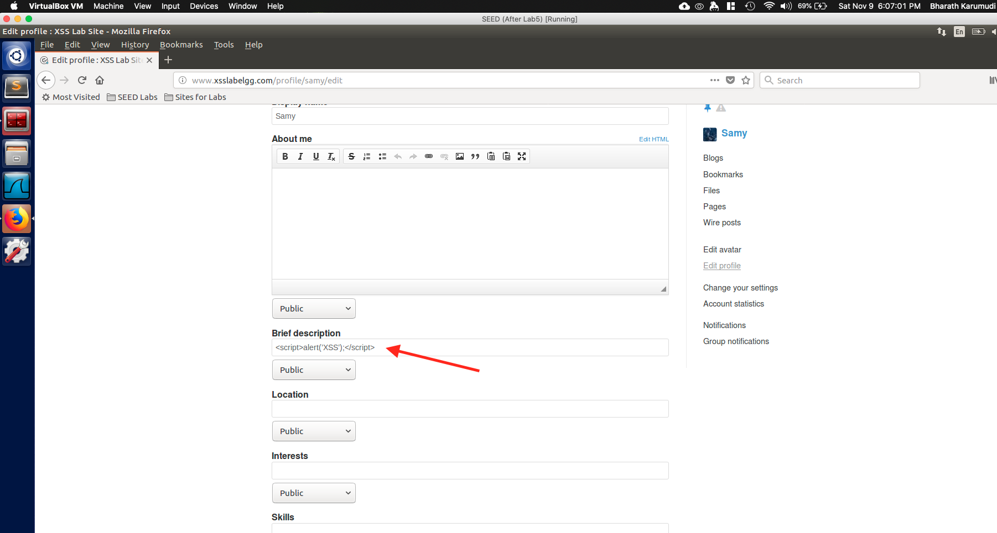

Fig: Samy updating his profile with java script.

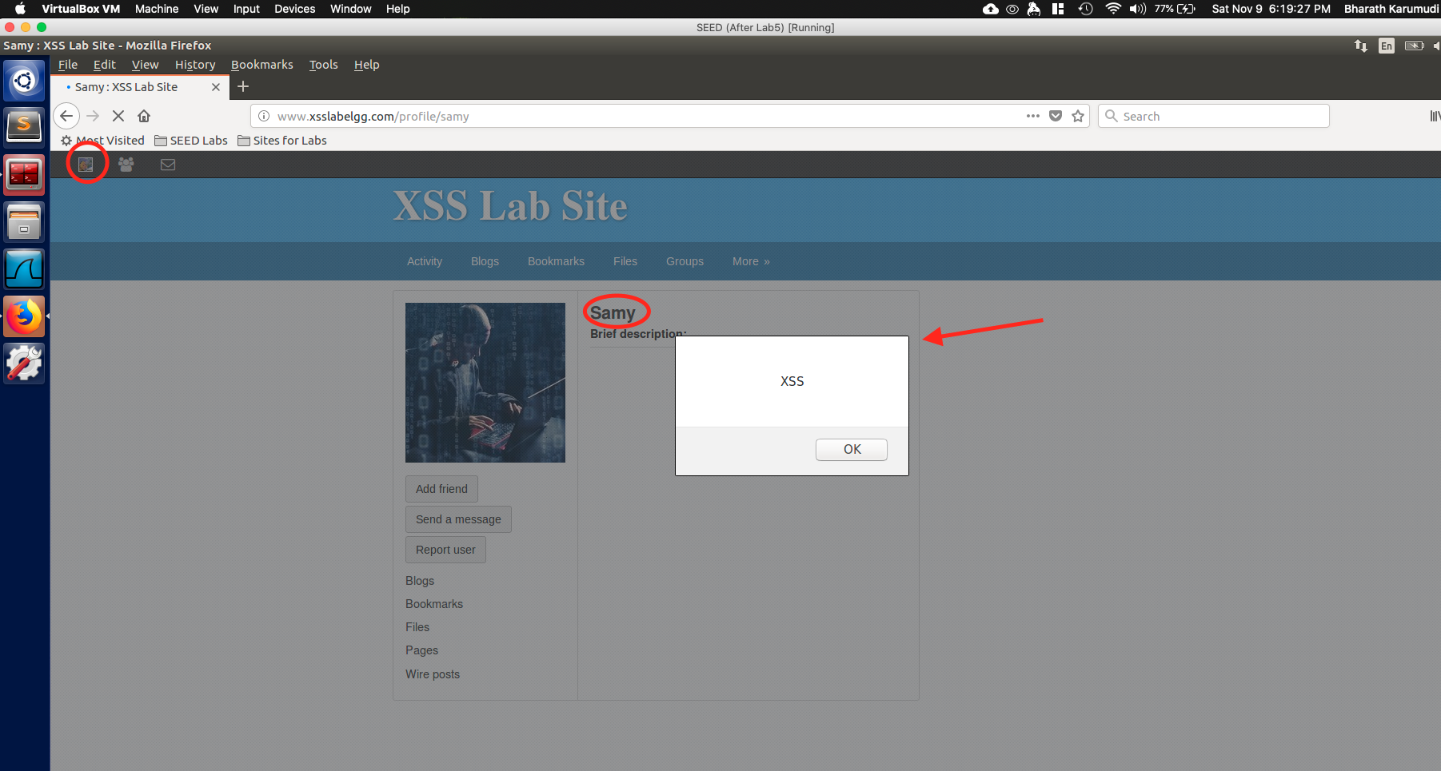

Fig: Alice viewing the Samy profile and got the alert.

Observation:

Explanation:

Task 2: Posting a Malicious Message to Display Cookies

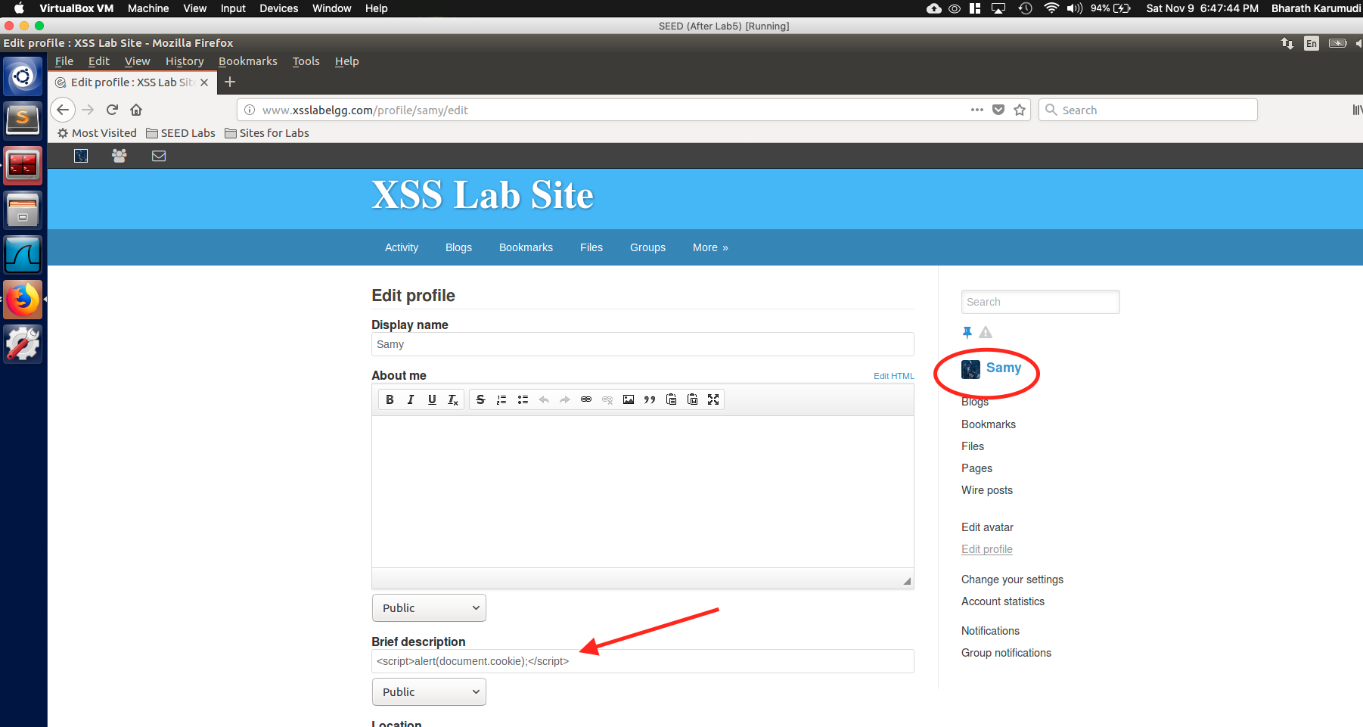

Fig: Samy updated his profile with malicious code to show cookie document

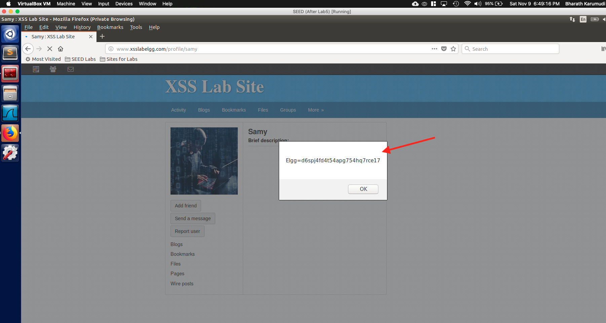

Fig: Alice seeing her cookie details when visited Samy profile

Observation:

Explanation:

Task 3: Stealing Cookies from the Victim’s Machine

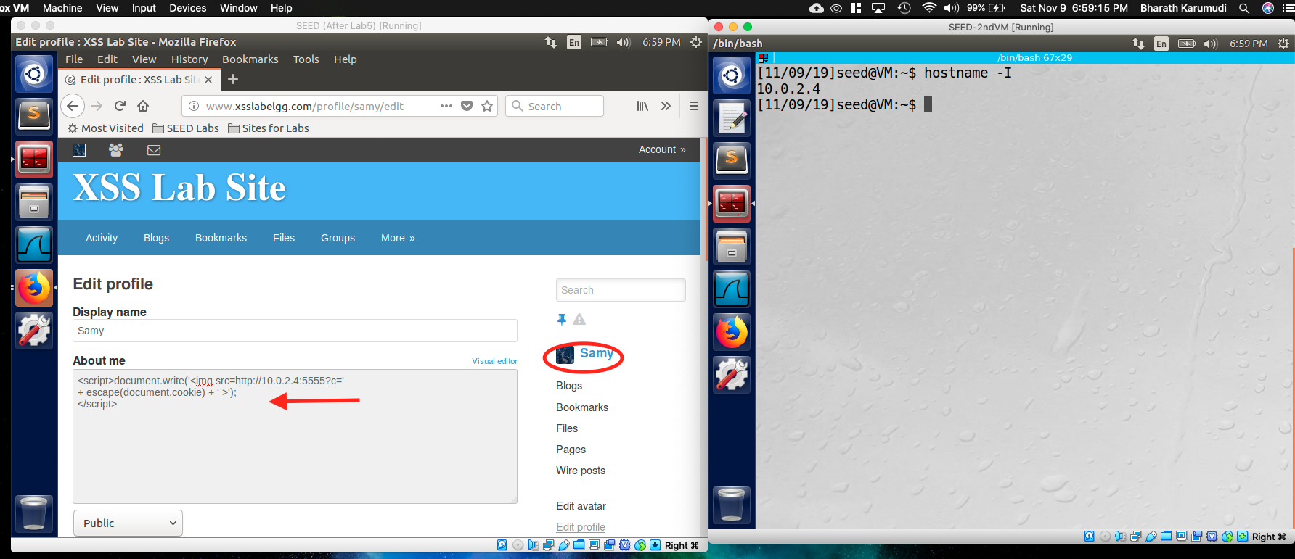

Fig: Samy updated JS code that sends the cookie details to remote machine

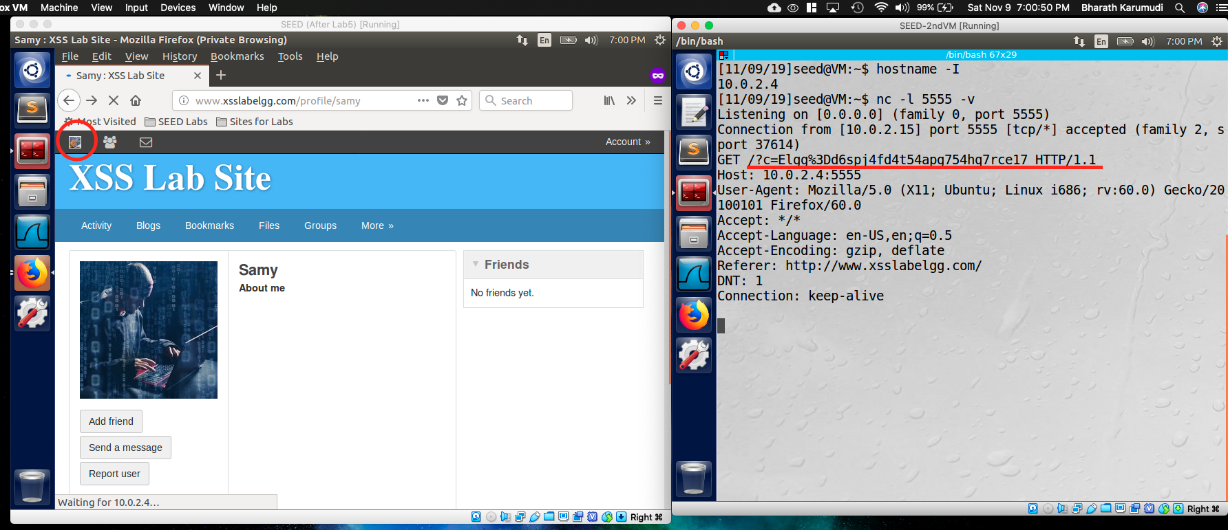

Fig: Alice cookie details are emitted on Samy terminal – remote machine

Observation:

Explanation:

Task 4: Becoming the Victim’s Friend

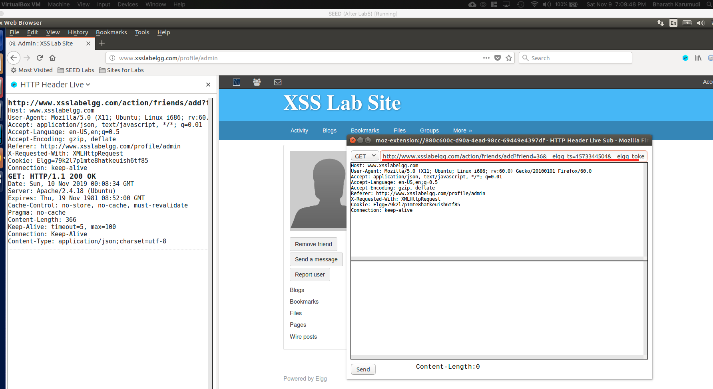

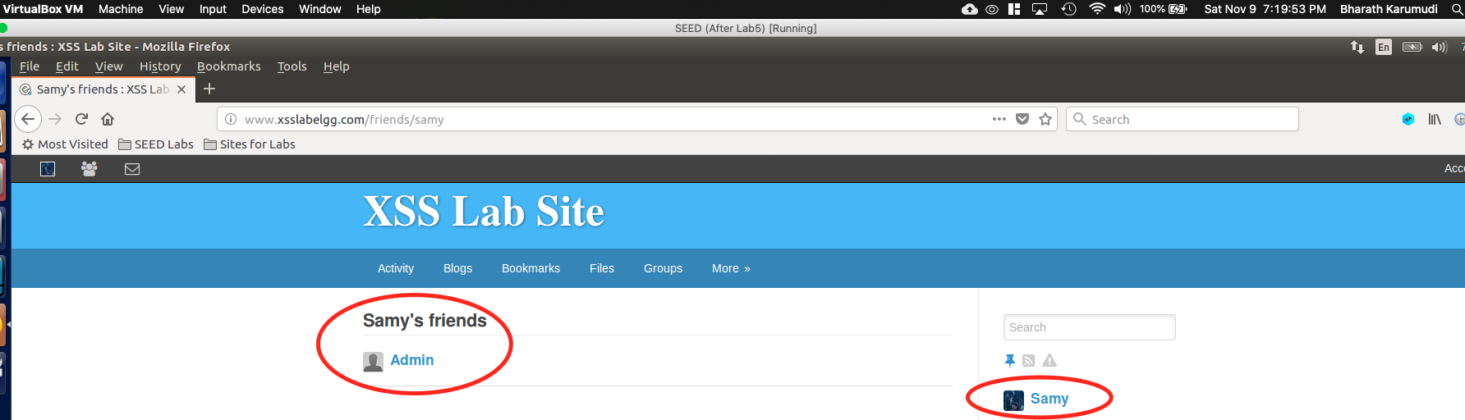

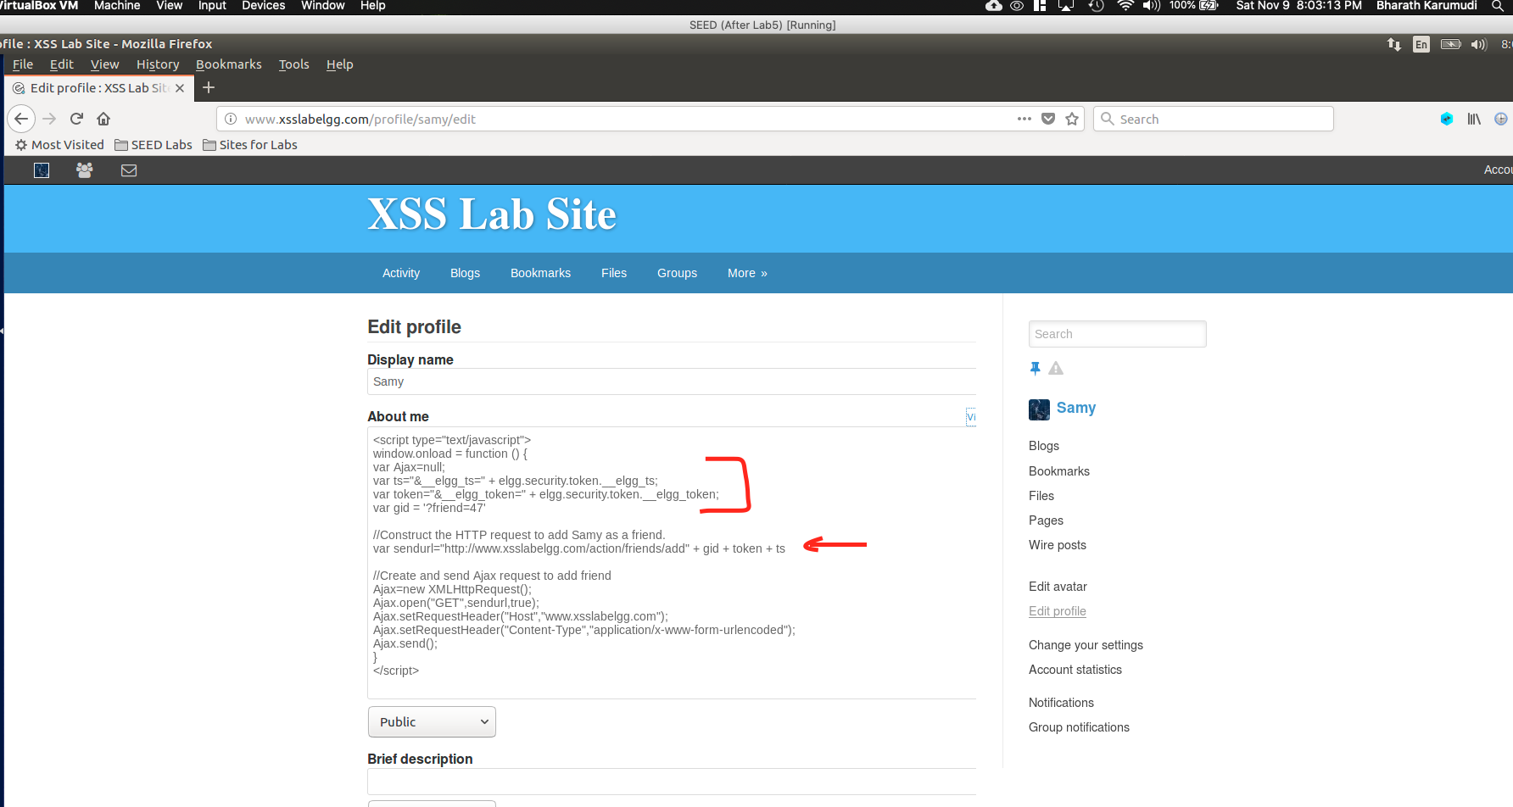

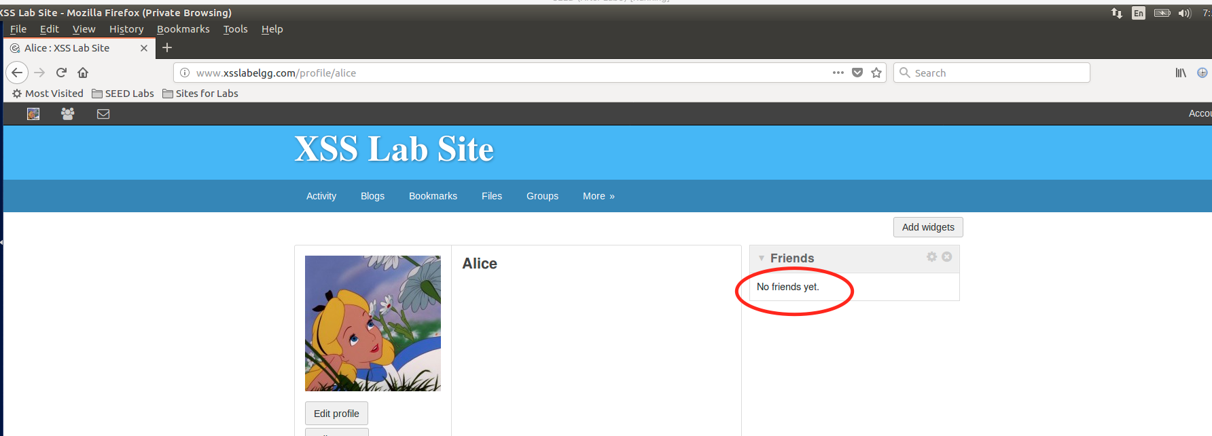

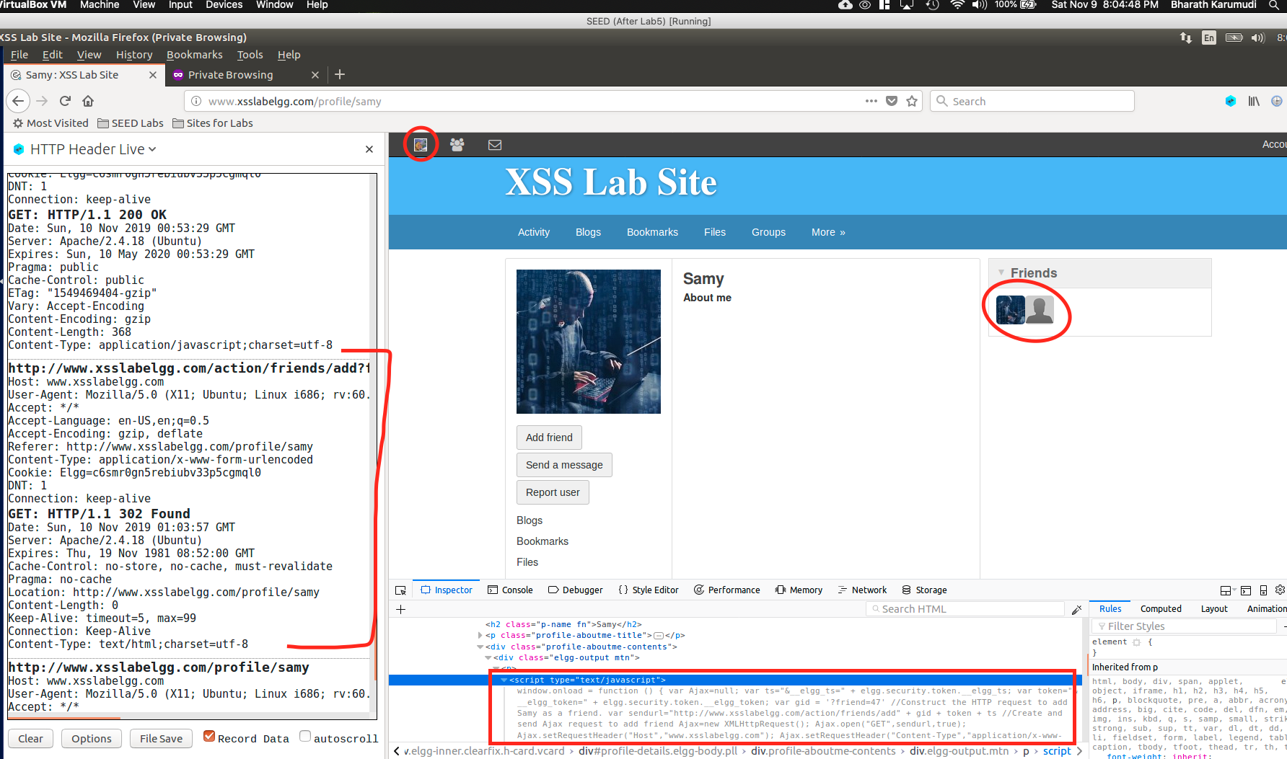

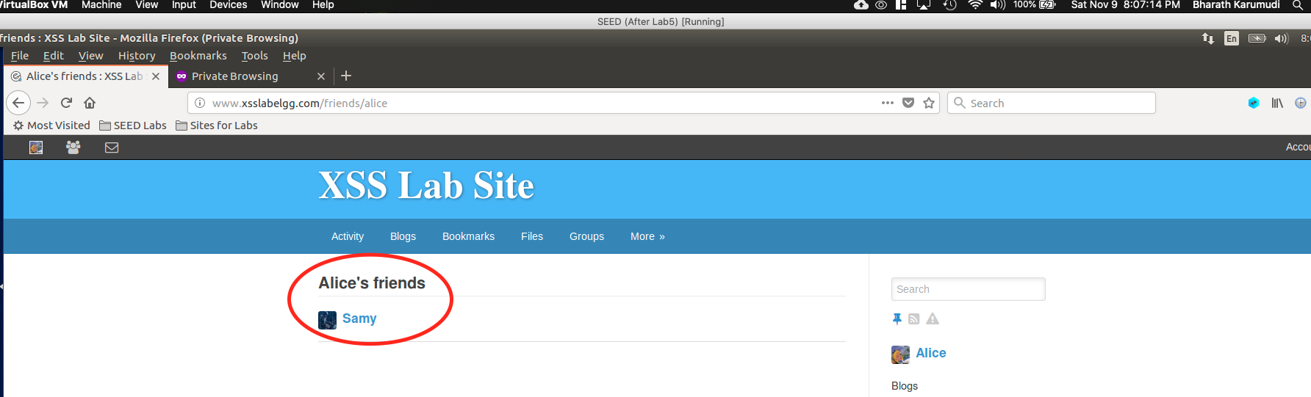

Observation:

Explanation:

**Question1:** The lines marked with 1 and 2 are needed to defend the CSRF countermeasure. Because, Elgg has CSRF defense which validates the user timestamp and session token. If the request comes with invalid tokens, the request will be rejected. So, we need to pass the timestamp and token to pass our requests.

Question2:

Task 5: Modifying the Victim’s Profile

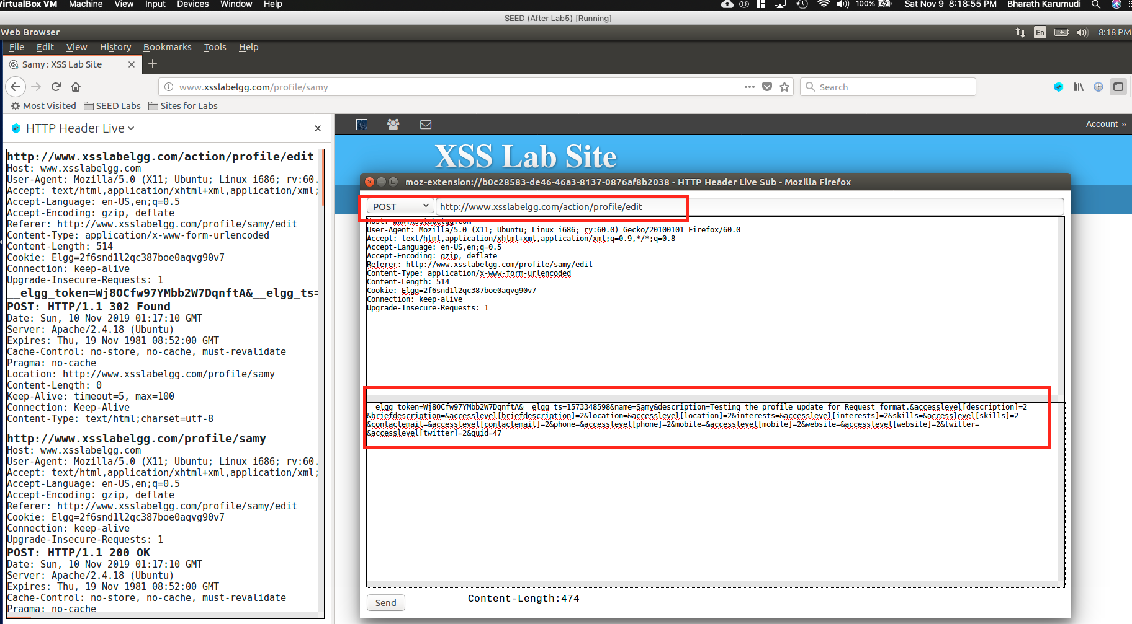

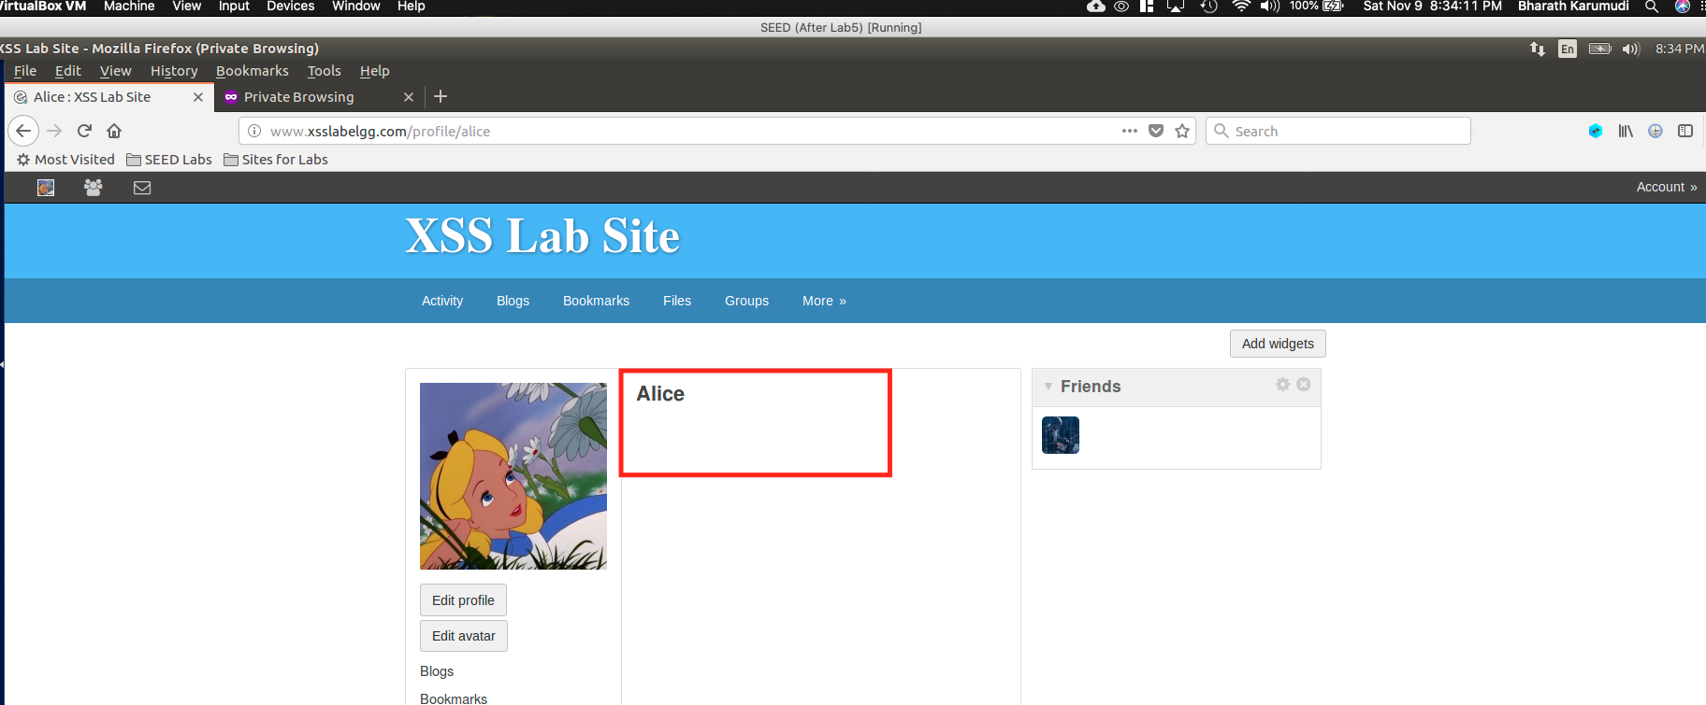

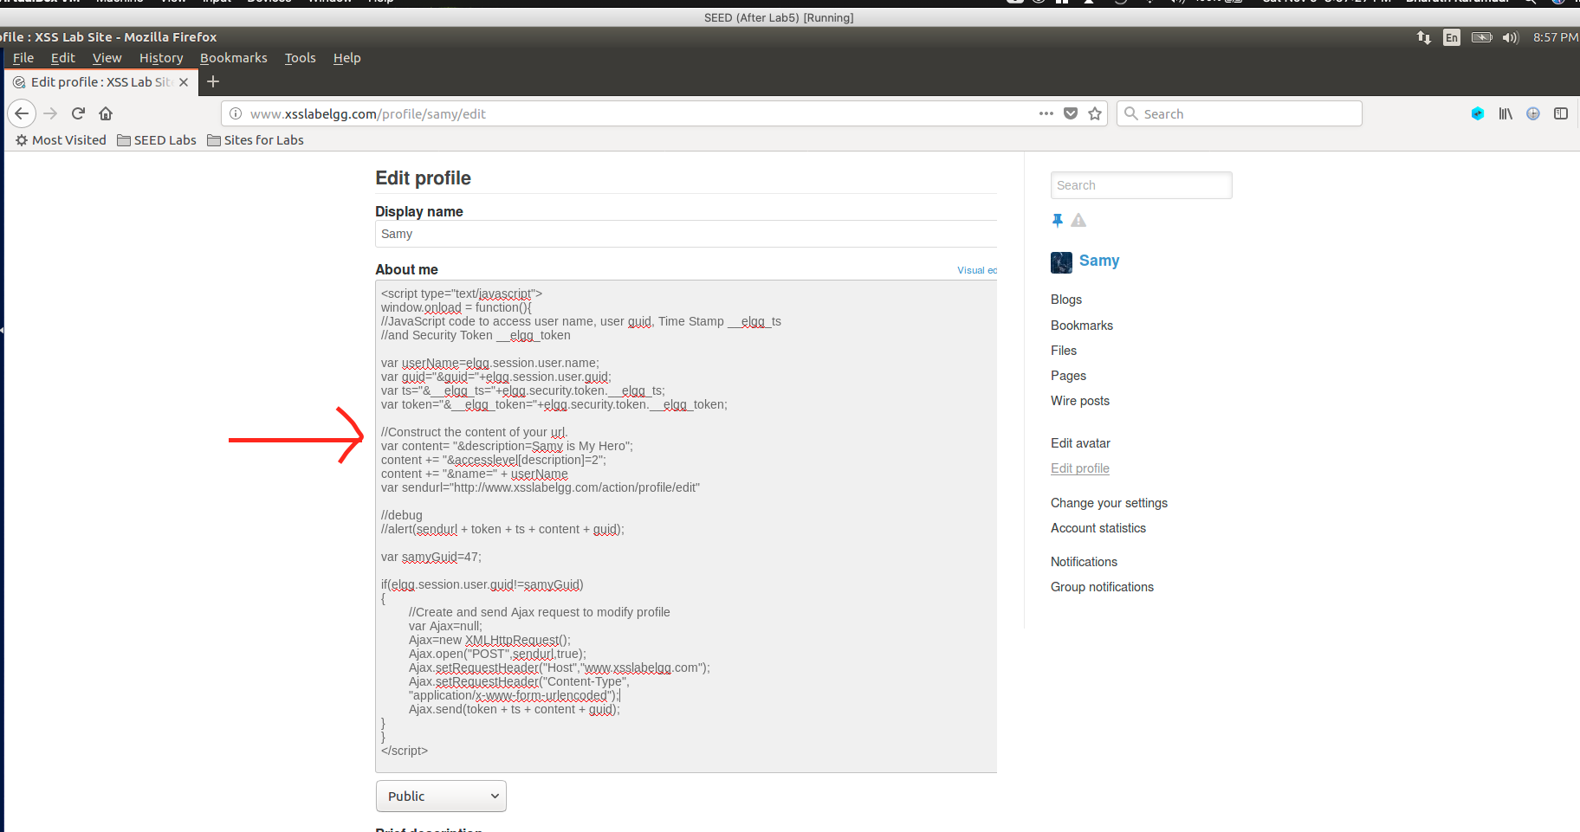

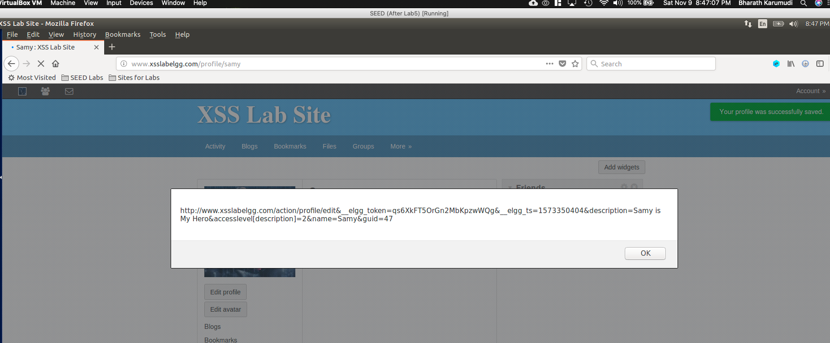

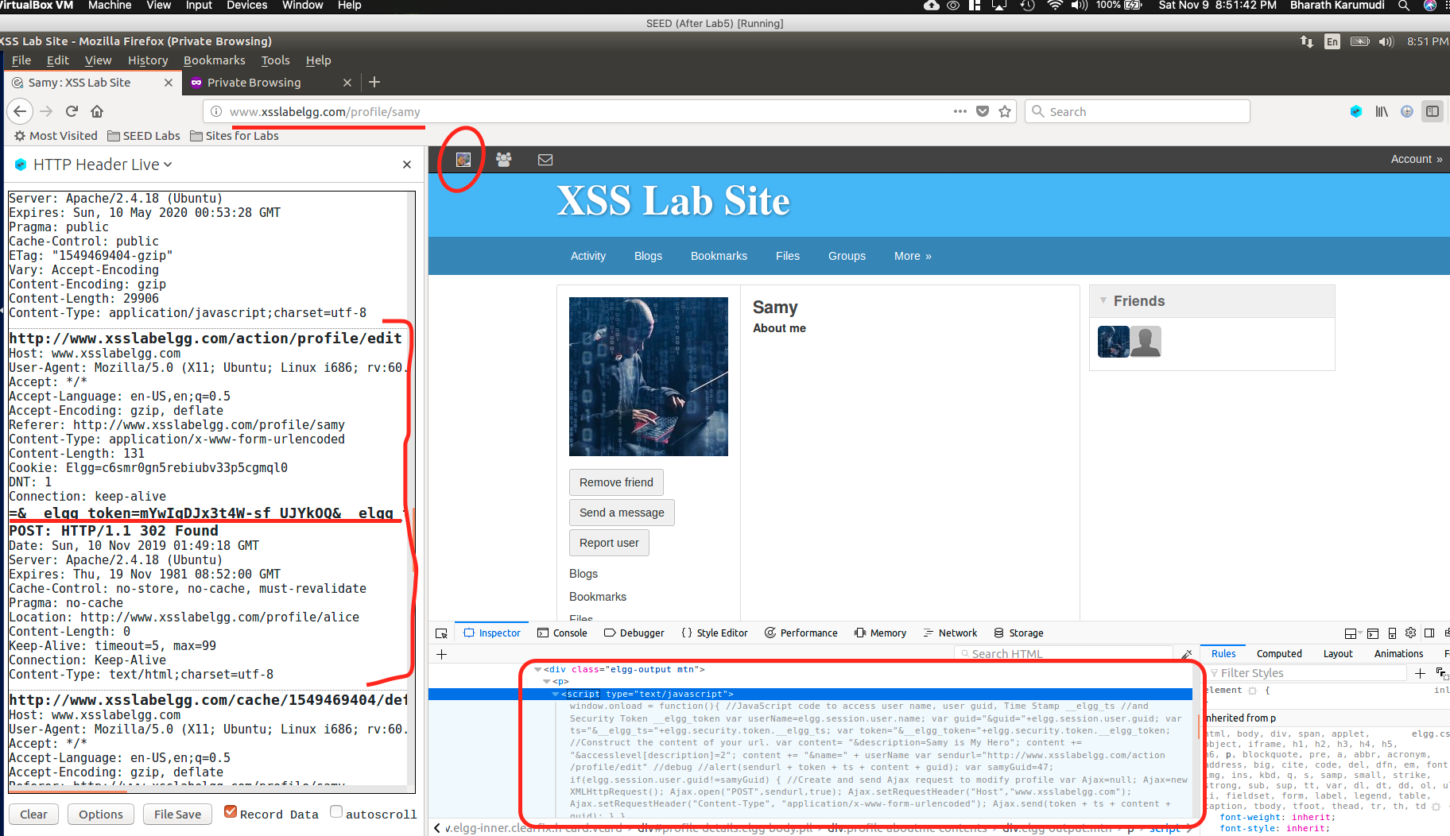

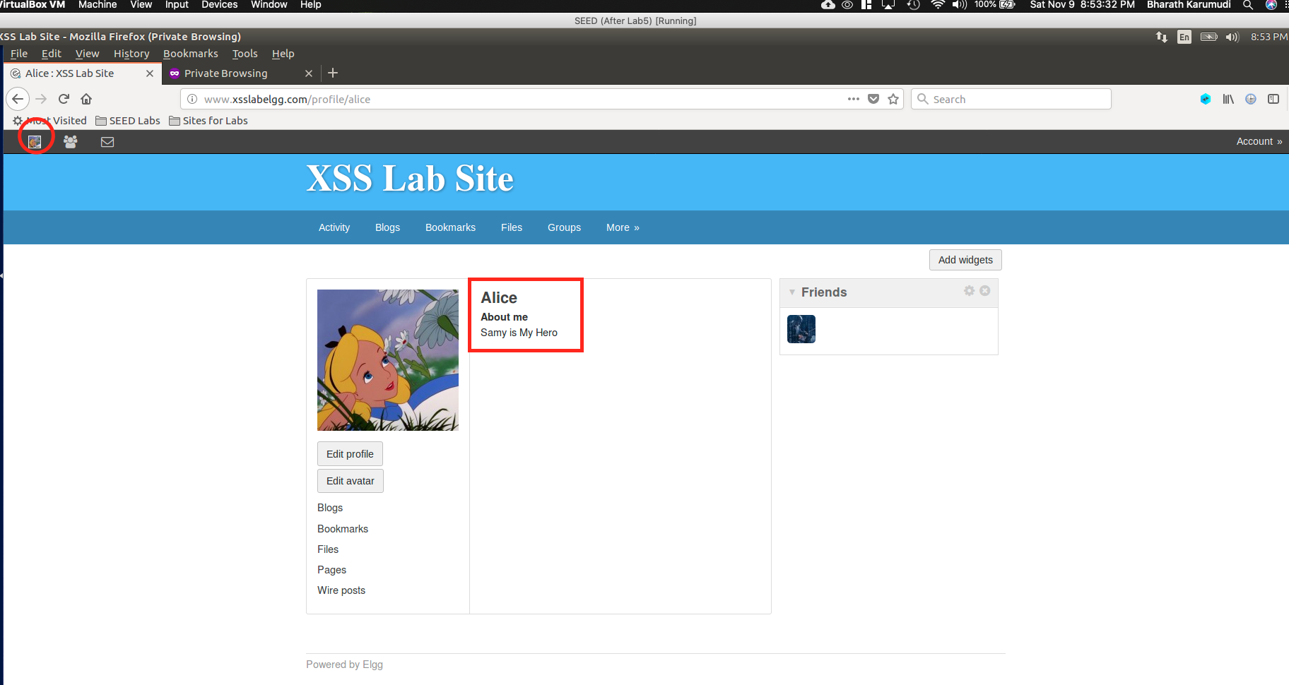

Observation:

Explanation:

Question3:

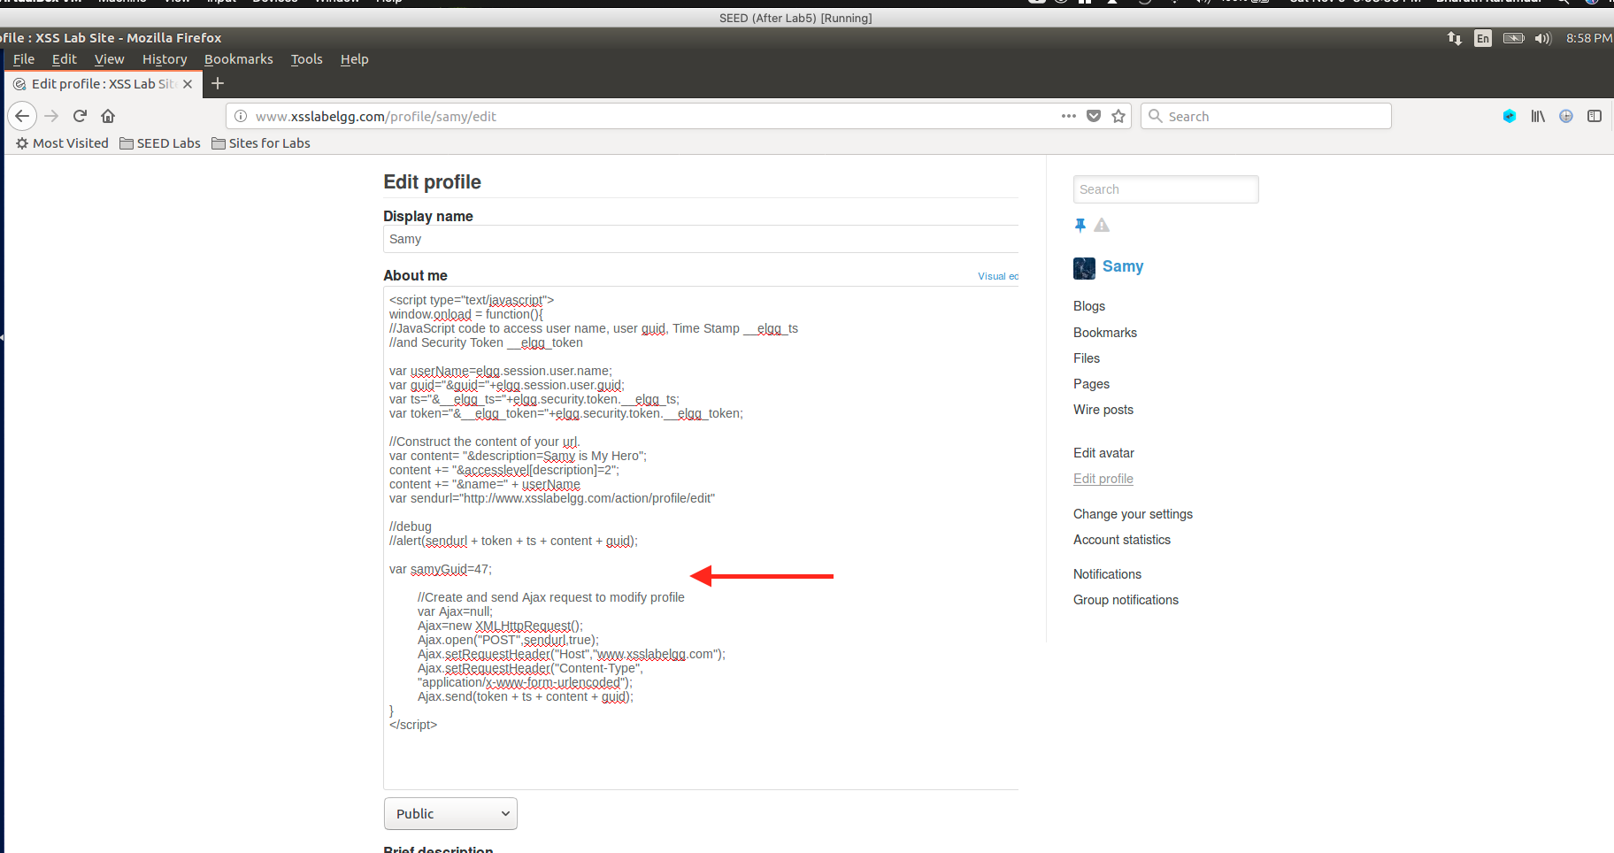

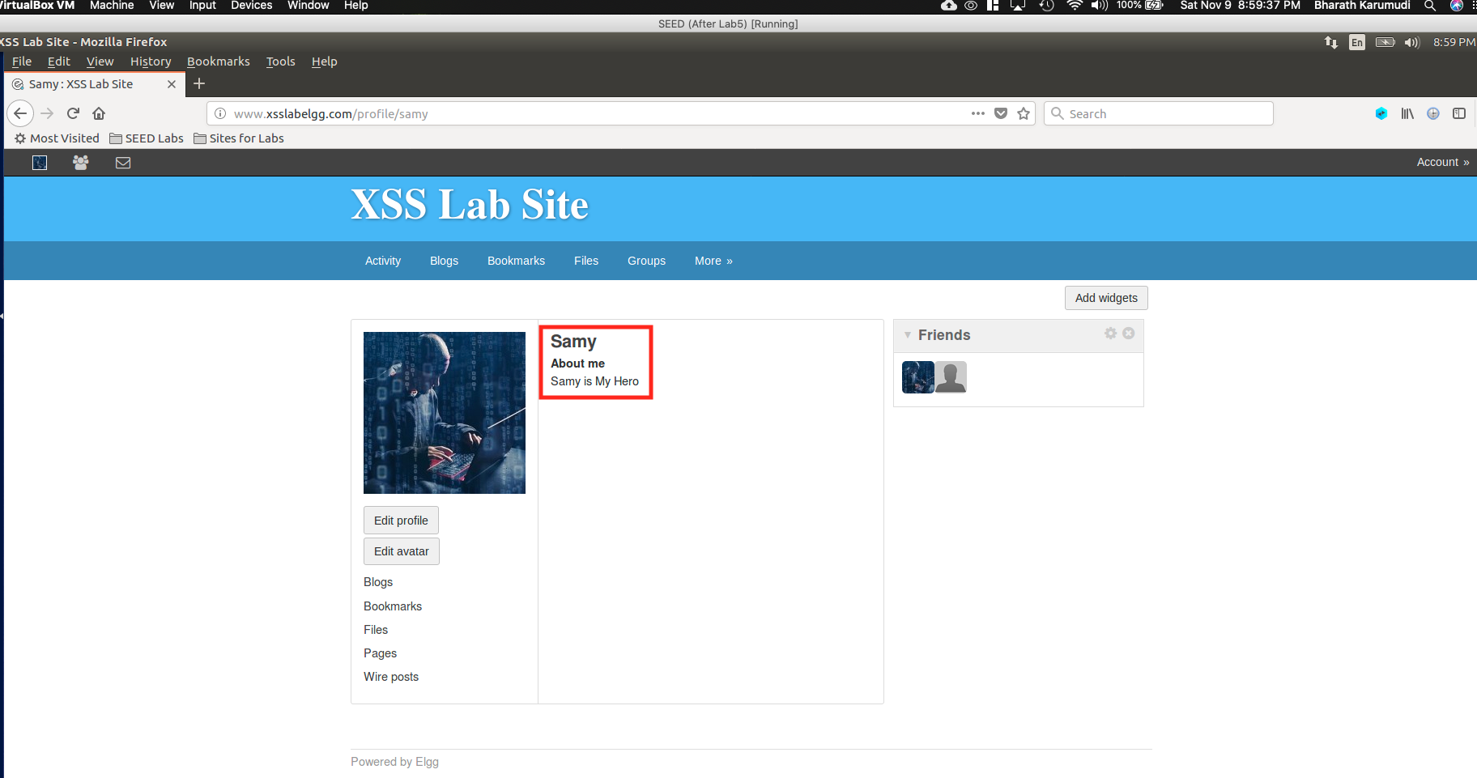

Q3 Observation: If we remove the Line1, where the if condition, then the profile update will happen to Samy also. Because the same JavaScript will get loaded for him on profile page load and does the profile update for Samy to “Samy is my Hero” by replacing the malicious code. After this, if anyone visits the Samy profile the attacks will not happen.

This was happened in Task 4, where Samy made friend of himself, because there is no such validation/constraint defined in the JavaScript.

Task 6: Writing a Self-Propagating XSS Worm

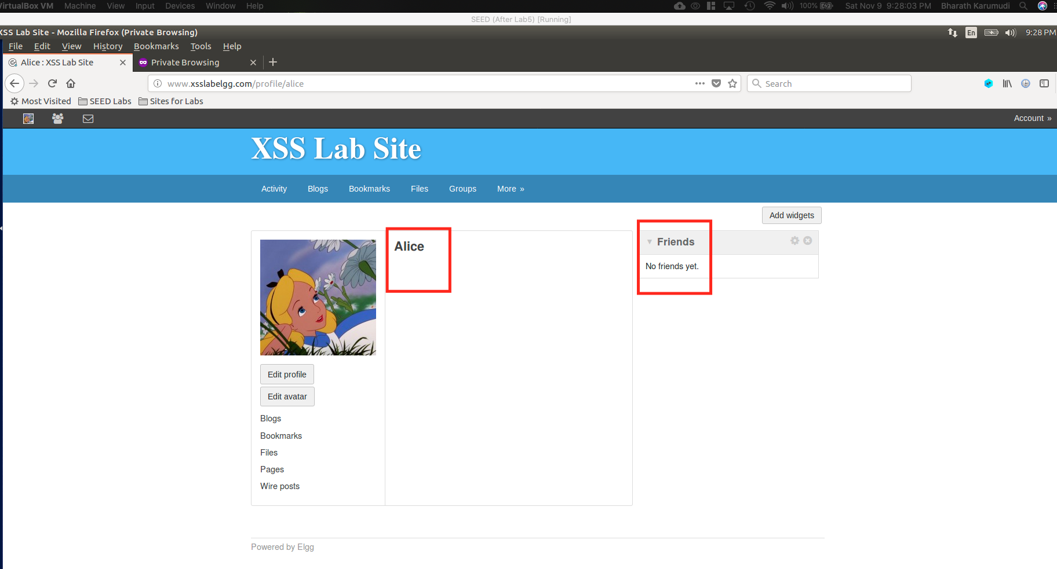

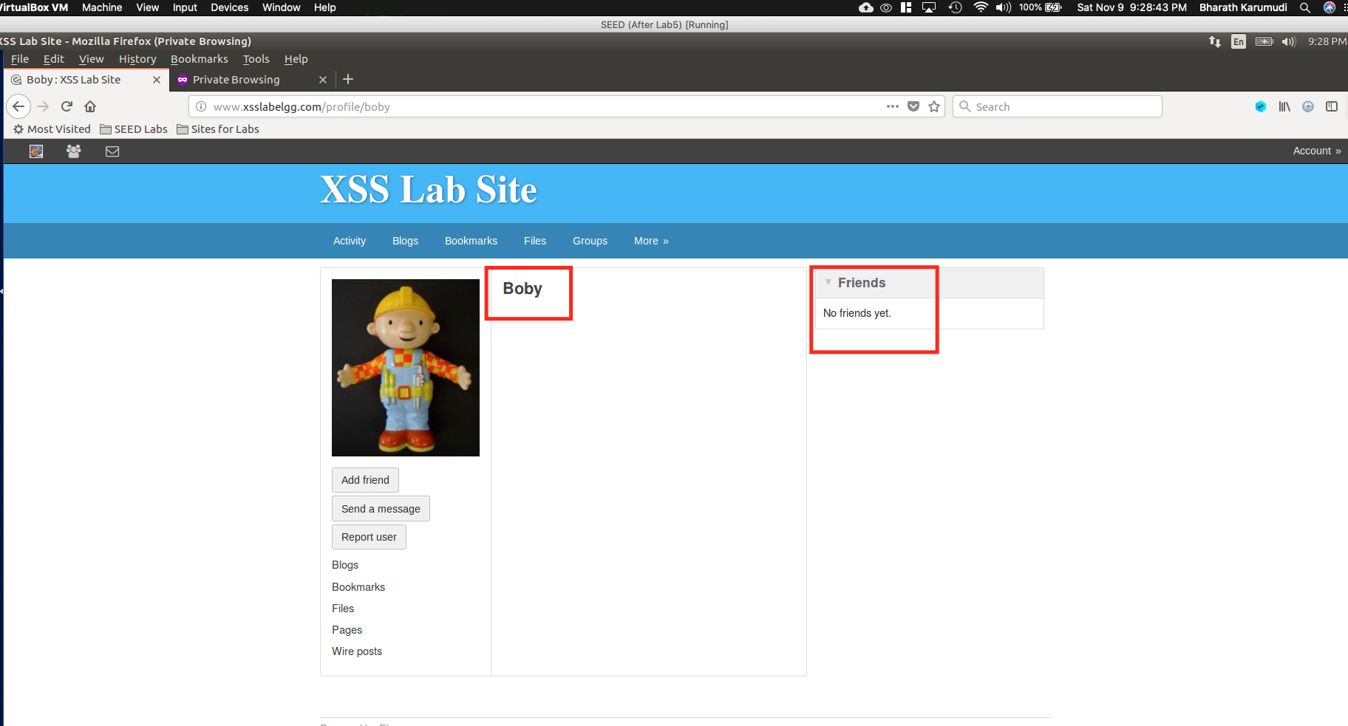

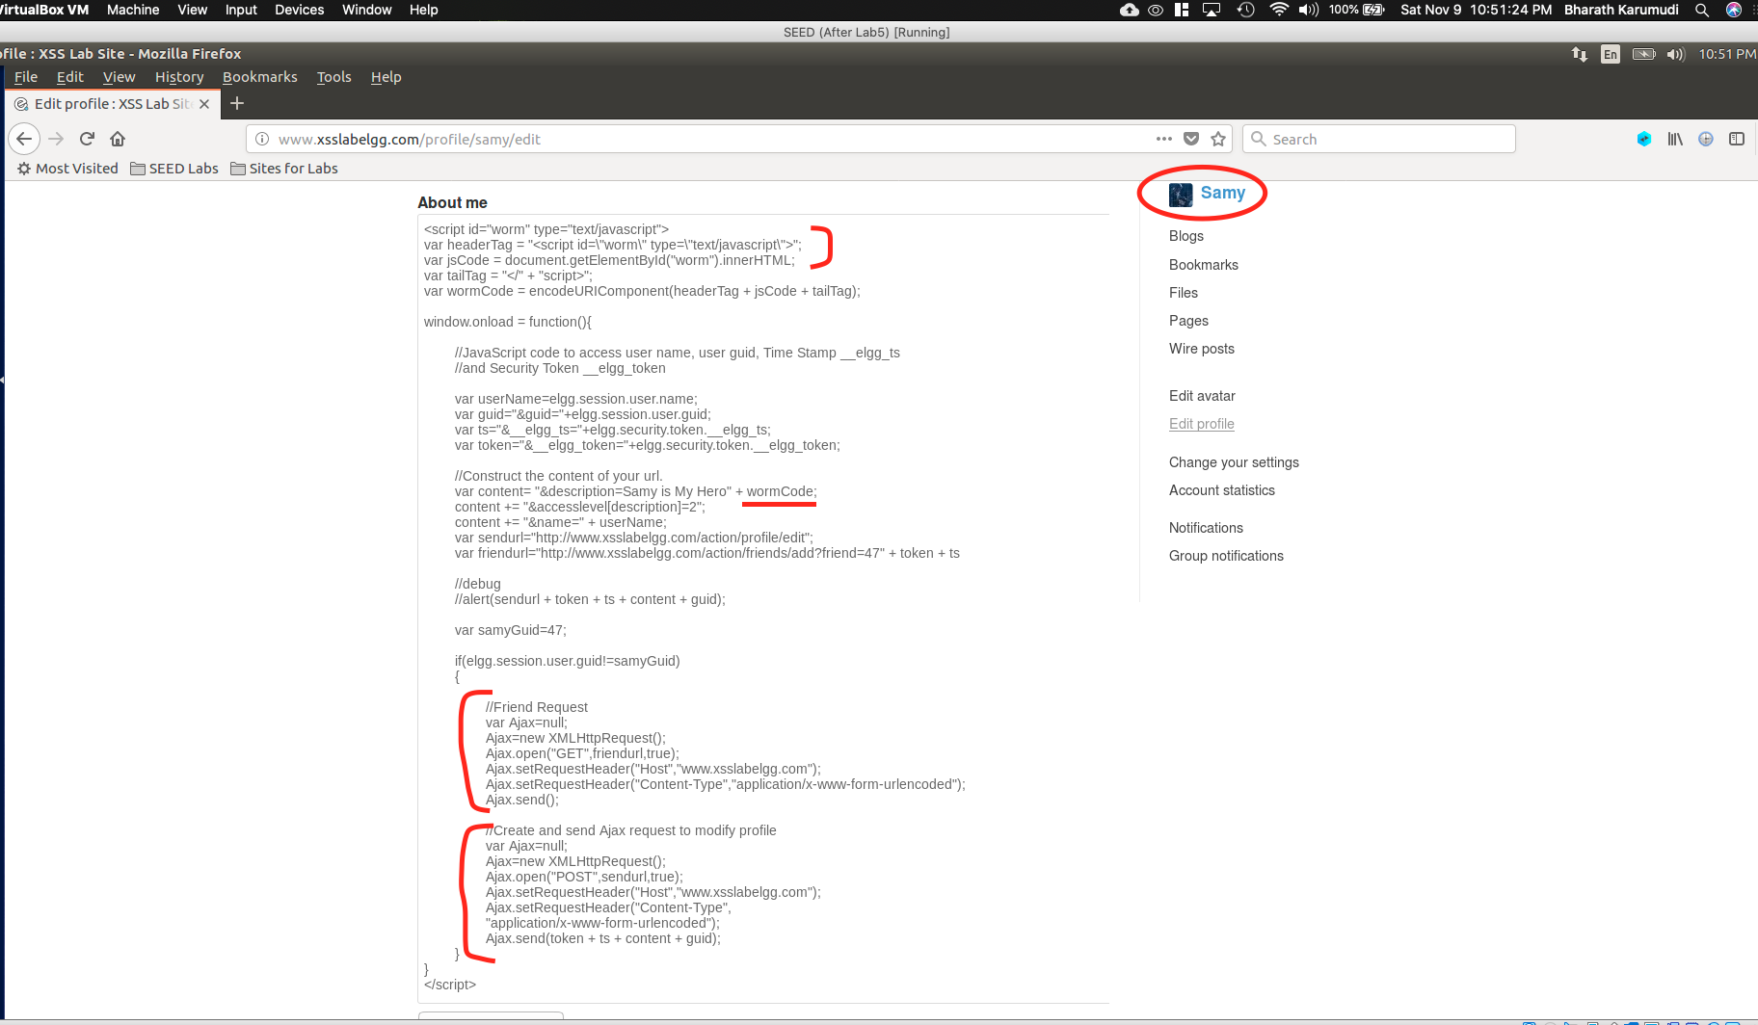

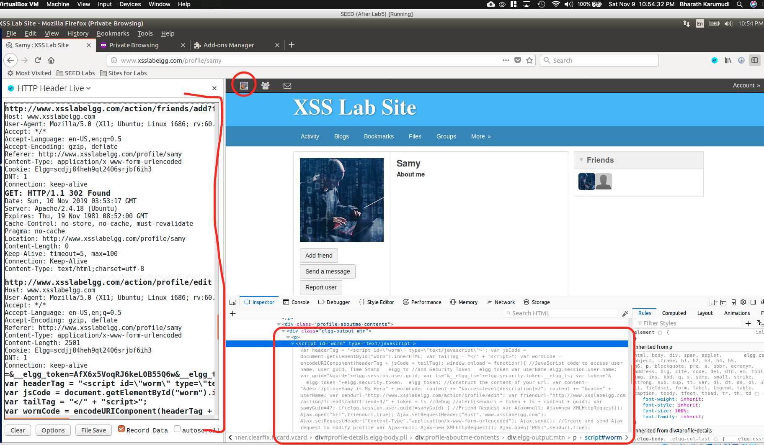

Fig: Alice viewed the Samy profile

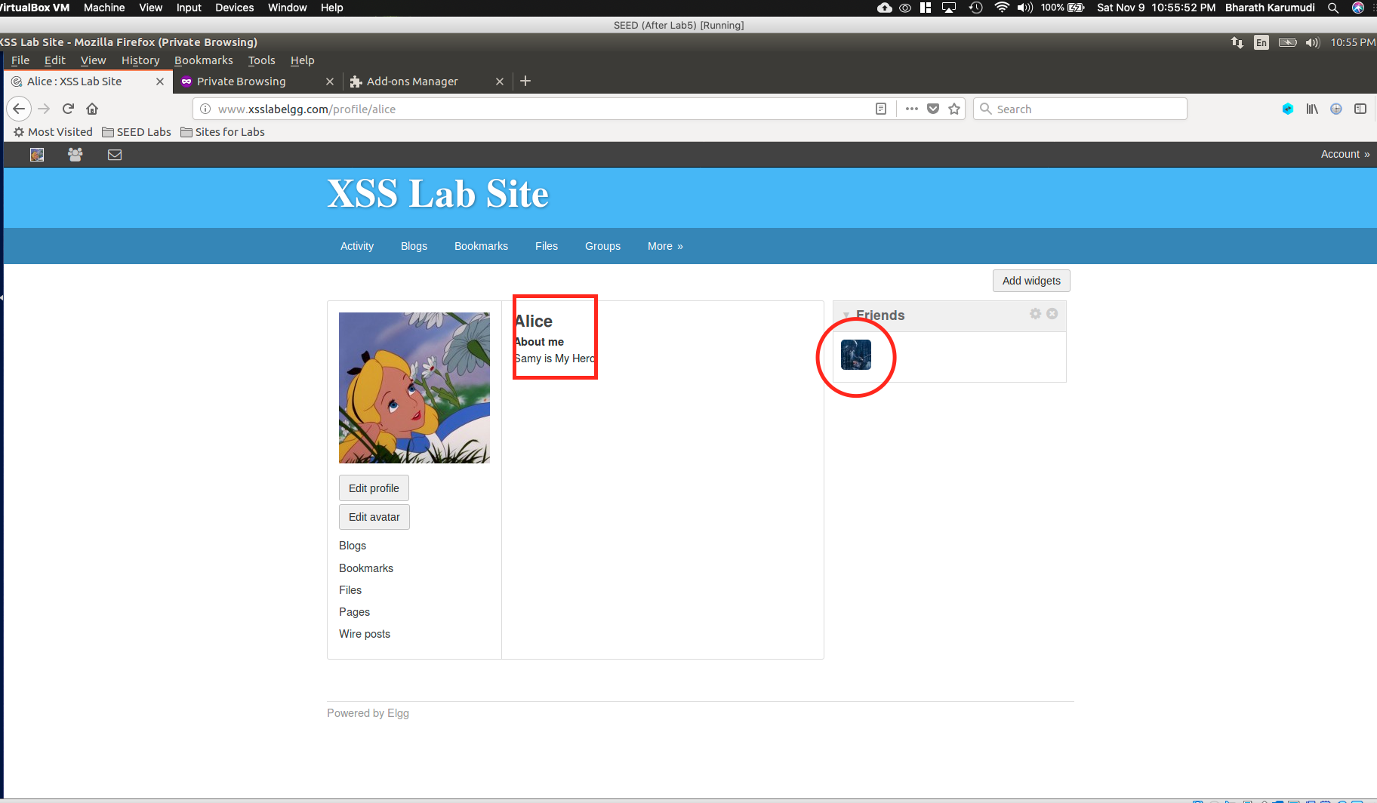

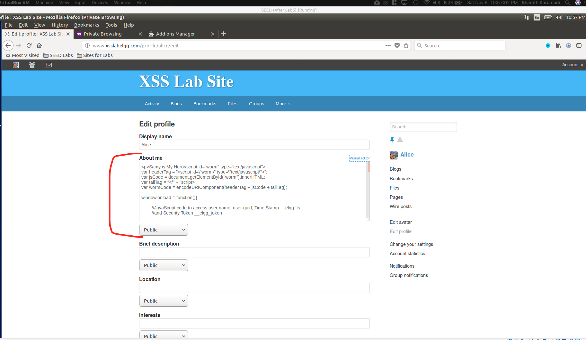

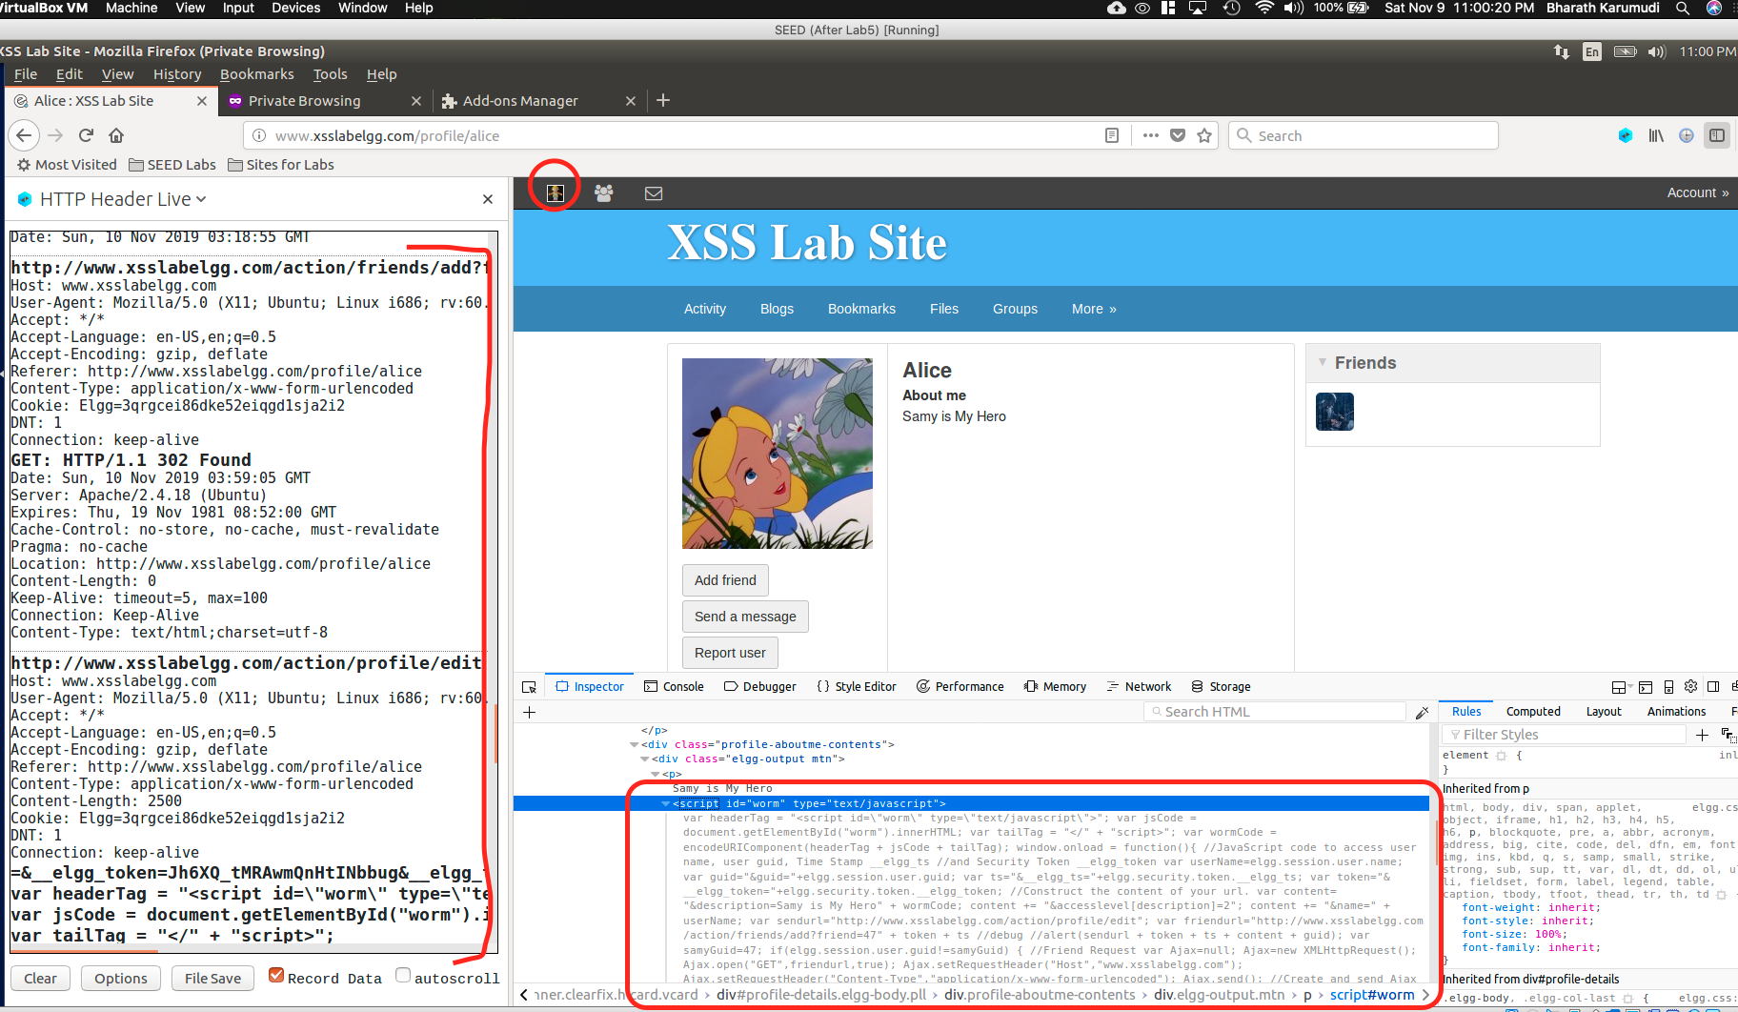

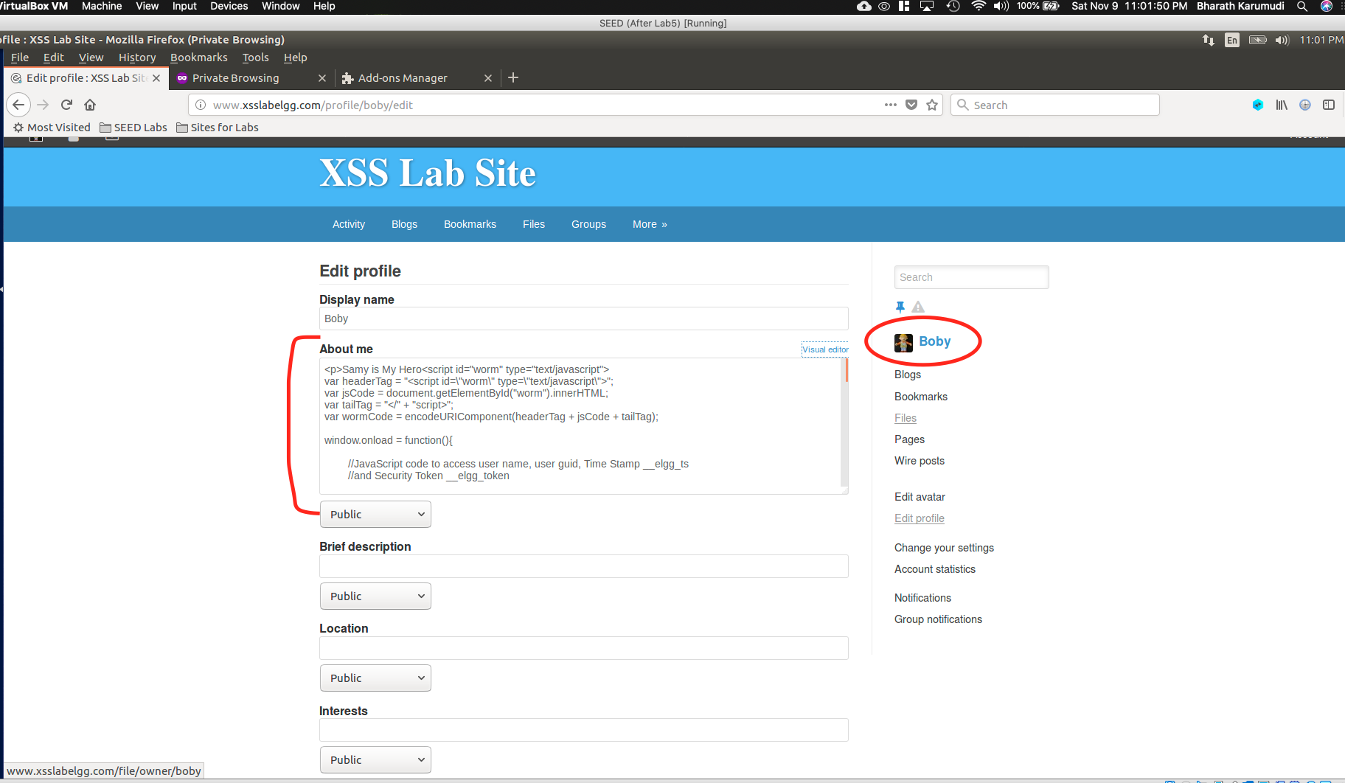

Observation:

Explanation:

Task 7: Countermeasures

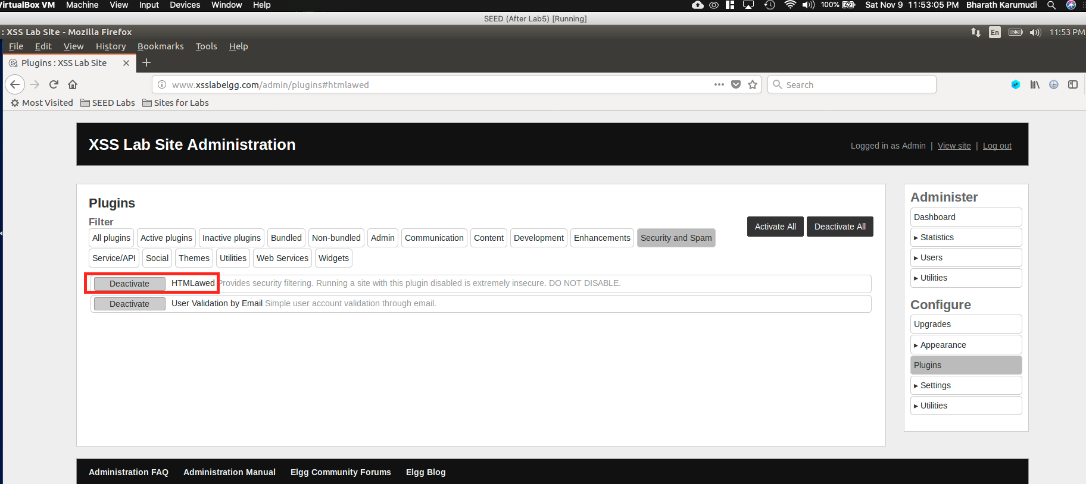

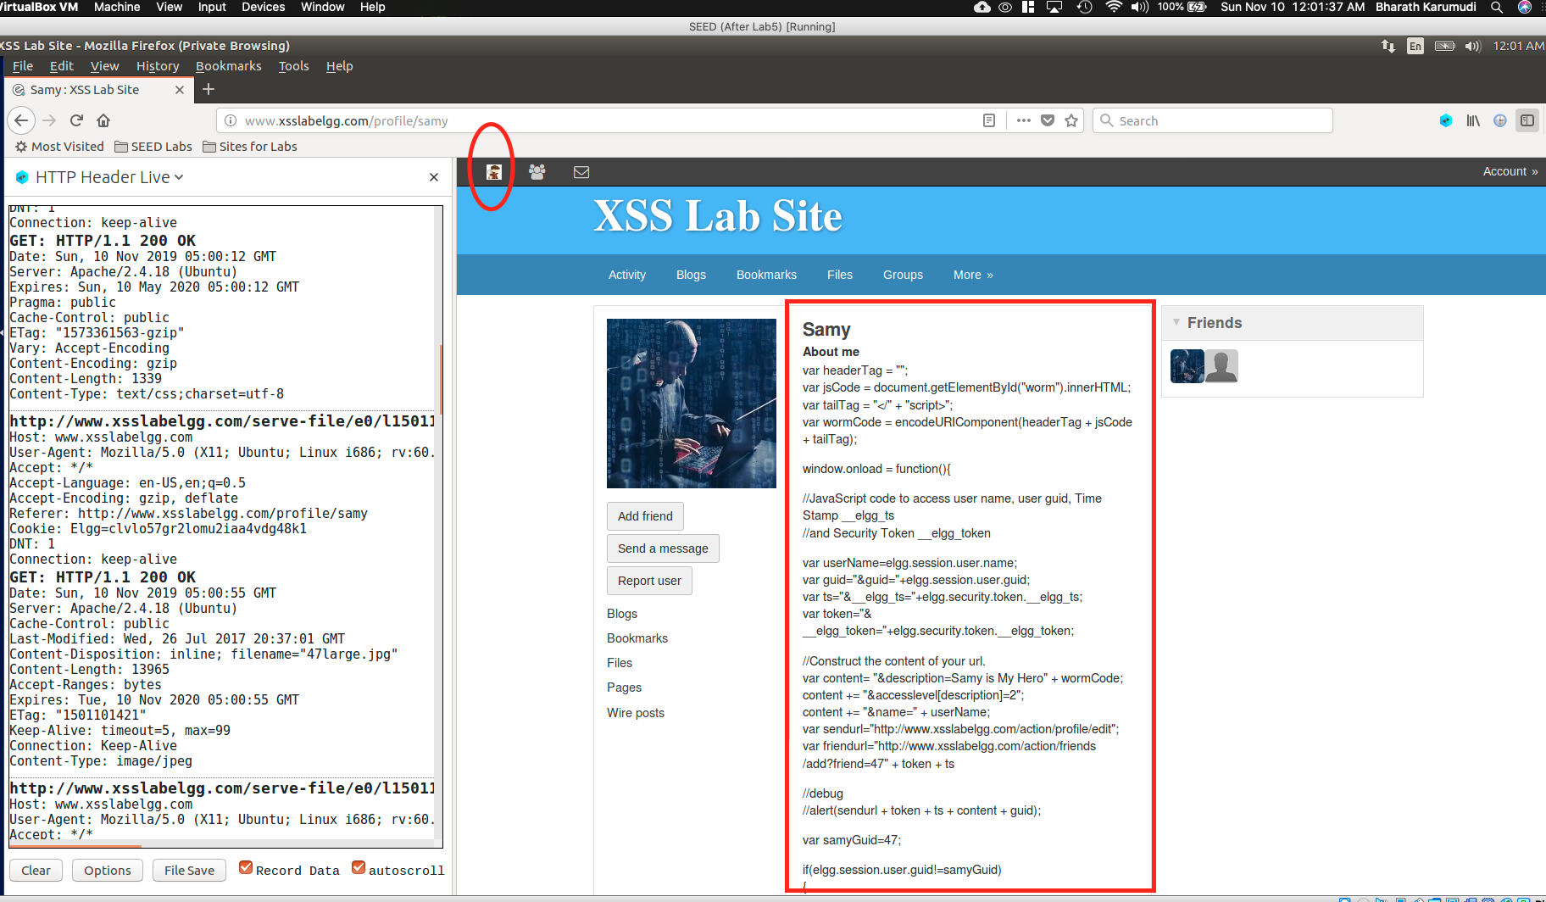

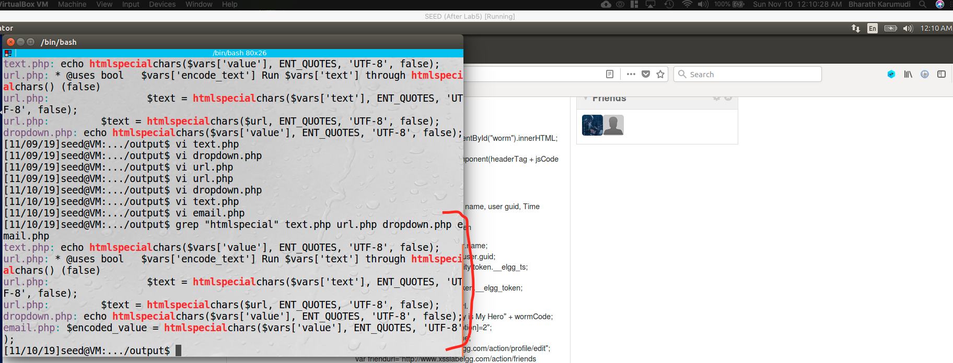

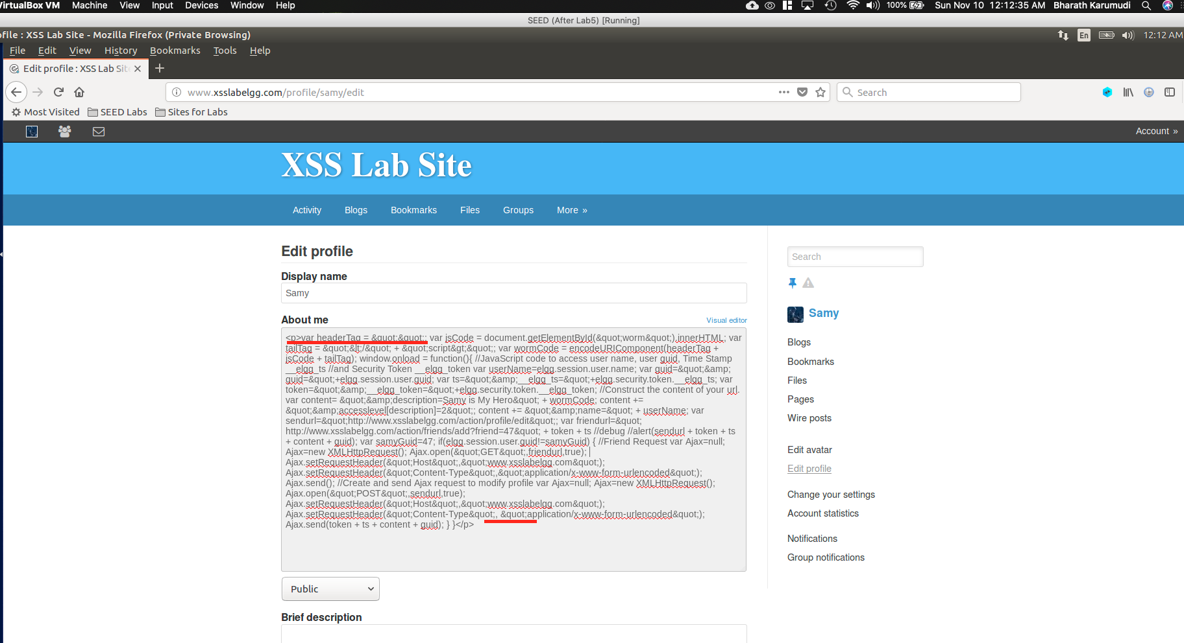

Observation:

Explanation: